

ASSET VERIFICATION AND RECORDING TOOL KIT


Plot 31, Bukoto Street
P.O Box 7657, Kampala, Uganda
+256 (0) 39 2000216/0772525235
email: cpa@cpa.ug

www.cpa.com

August to September 2026

VERIFICATION DETAILS

NAME OF THE REGION: | EASTERN REGION
SUB-REGION: | BUSOGA REGION
Name of Local Government | MAYUGE DISTRICT LOCAL GOVERNMENT
VERIFIER PARTICULARS
Full name | KIYUBA SALIMU
Contact/ email and Telephone | 0755215778, kiyubasalimu@gmail.com
Supervisor/ Sub team leader | NANDUDU SULAINA
Name | WANDERA SOLOMON
Contact | 0708153235, wanderasolo@gmail.com
Date of submission

HEALTH CENTRES
INFORMANT INTERVIEW/DISCUSSION GUIDE (INCHARGE OR RESPONSIBLE PERSON)

Name of Health Centre: BUKENDI HEALTH CENTRE III

1a | Does the Facility have a record of all assets provided under UgIFT.  (Obtain a record and verify if it has the costs and numbers supplied | YES
1b | If Not ask how many were supplied and when.

2 | How does this facility Maintain (repair/service/replace) the assets provided under Ugift  - It is maintained by the facility officials in charge(MR SSEGONGA JAME) in this case

3 | Does the facility take regular record about functionality/ or breakdown of the assets provided? | In case of blockage, the one MR SSEGONGA JAME (facility in charge) said that they normally use a counter book to record all equipment broken.

4 | How has the UgIFT support helped in service delivery in the area, any issues, challenges and any recommendations for better program implementation. | BENEFITS OF UGIFT IN THE AREA  - The UgIFT has consistently helped in supplying health equipements to the facility and this has eased admissions hence managing the overwhelming at the facility.  - It has also helped in the accommodations of staff by building staff quarters near the facility. This has reduced absenteeism at the facility since officials are ever present at the facility.  - It also increased the health workers at the facility hence reducing the overwhelming health to patient ratio.  - It has also improved the facility sanitation because of the increased number of assets at the facility like the placenta pits, pit latrines and bathrooms for patient.  - Labor wards and available equipment for labor such as labor beds and labor suits have created enough space for mothers in labor hence reducing congestion.  - Because of the available assets the facility can now handle overwhelming admissions hence reducing unnecessary referrals.  ISSUES AND CHALLENGES  - The Lab is generally very small hence causing delay in service.  - Inadequate inventory store at the facility and has forced the facility to improvise the men’s ward into a store and the men are now admitted together with ladies in the same female ward.  - Adult beds are not enough. .  - Theft and threats attributed to lack of a perimeter fence. Hence putting health officers and patients at stake.  - Stock Outs and delays of restocking is really a big challenge hence hindering admissions and normal treating of the patients.  RECOMMENDATIONS  - we recommend that the OPD facility be increased to reduce the overwhelming daily admissions at the facility.  - we also recommend a perimeter wall to be installed at the facility since they lack one to improve on the security

PROCEED TO VERIFICATION AFTER THIS DISCUSSION

Health centre checklist

NAME OF LG : LUUKA DISTRICT
NAME OF HEALTH FACILITY : BUKENDI HEALTH CENTRE III

Equipment/ Item | Department | Item  Description | Life in Months | Tag Number ( engrave no.) | Date Of Purchase | Date Placed In Service | Recoverable cost | Cost | Acc Dep Cost | Net Book Value | Ytd Deprn | Equipment status | Remarks
B.P. Machine, aneroid | health | It is white in color model 2088C with a black surface and a rectangular screen |  | Not engraved | 15/11/2025 |  |  | 600,000 |  |  |  | Received 2 and all still functioning. | All the 2 that were received were verified and are all functioning
Autoclave 20 Liters.,Duo Operated | health | It has a gauge, white in color, with a black metallic base mounted on the wall |  | Not engraved | 24/09/2025 |  |  | 900,000 |  |  |  | Not received | Not verified
Bowl, Kick | health | Standard silver steel medical bowl with mobile kick stand |  | Not engraved | 15/11/2025 |  |  | 400,000 |  |  |  | functional | 1 Received  Not verified
Bowl Stand | health | Tall Silver like basin with 5 wheel stands, silver in color. Stainless in nature with a ring stand |  | Not engraved | 15/11/2025 |  |  | 389612 |  |  |  | Well-functioning | 2 bowls received and all verified,
Counting chamber Neubauer Improved | health | It’s a clear glass improved device with silver etched grid and 2 transparent covers slips in blue plastic case. |  | Not engraved | 15/11/2025 |  |  |  |  |  |  |  | 2 received, verified, in use.
Cupboard Steel, Lockable | health | Large, Grey in color with double door, lockable in nature |  | Not engraved | 24/09/2025 |  |  | 3,000,000 |  |  |  | functioning | 2 verified and all functioning`
Drip Stand | health | 5 wheels with a straight vertical stand and locks adjustable in nature |  | Not engraved | 15/11/2025 |  |  | 400,000 |  |  |  | functioning | 8 received and verified
ESR Stand | health | A standard metallic grey metal with adjustable leveling for holding tubes. |  | Not engraved | 15/11/2025 |  |  | 150,000 |  |  |  | functional | 1 verified,
Examination Couch | health | 4 silver stands with a black soft sponge mattress with a lifter. It is a bed |  | Not engraved | 24/09/2025 |  |  | 600,000 |  |  |  | functioning | 2eceived and verified
Examination light,LED | health | Tall, white /silver adjustable goose neck lamp with 5 white wheel |  | Not engraved | 24/09/2025 |  |  | 600,000 |  |  |  | functional | 2 received and verified
Glucometer | health | White in with a strip tiny hand held plastic device |  | Not engraved | 15/11/2025 |  |  | 50,000 |  |  |  | 1 functioning and 1 not functioning | All verified
Height Meter | health | A tall vertical metallic stand, silver in color with flat base and sliding head and height scale. |  | Not engraved | 24/09/2025 |  |  | 250,000 |  |  |  | functional | I verified and in use
Instrument Trolley | health | Silver in color with 2 partitions and 4 black wheels. Stainless steel trolley |  | Not engraved | 15/11/2025 |  |  | 1,600,000 |  |  |  | functioning | 2 received and 1 verified
Microscope Binocular | health | White in color and a black base.  With dual eye piece |  | Not engraved | 24/09/2025 |  |  | 700,000 |  |  |  | functioning | 1 seen and functioning
Otoscope | health | Small, white handheld touch like type with a cone tip for ear examination |  | Not engraved | 15/11/2025 |  |  | 100,000 |  |  |  | functioning | 1 Verified but just kept
Patient Screen | health | Tall white fabric, foldable metal partition equipement. 4 wheels with a black soft sponge mattress, 2 handles. |  | Not engraved | 15/11/2025 |  |  | 600,000 |  |  |  | functioning | 4 seen and verified
Patient Trolley | health | Large silver metal with 4 wheeled stretcher bed. |  | Not engraved | 15/11/2025 |  |  | 5,000,000 |  |  |  | functioning | 2 verified and functioning
Refrigerator, Basic | Health | Medium sized, Grey in color with 2 compartments , the lower one bigger than the upper one |  | Not engraved | 15/11/2025 |  |  | 4,000,000 |  |  |  | functioning | 1 verified and functioning
Stethoscope | Health | Black in color with 2 rubber flexible tube |  | Not engraved | 24/09/2025 |  |  | 1,200,000 |  |  |  | All functioning | 4 verified
Stop Watch | health | Handheld digital timer with start, stop and reset function |  | Not engraved | 15/11/2025 |  |  | 800,000 |  |  |  | functional | 2 received and verified
Stretcher | Health | It’s a bed with 4 black wheels ,two rails and black soft sponge |  | Not engraved | 15/11/2025 |  |  | 2,400,000 |  |  |  | All Functioning | 1 received and verified
Stove, Gas | health | White in color, 6kg(stabex) with 4 metallic banners |  | Not engraved | 15/11/2025 |  |  | 800,000 |  |  |  | working | 1 received and verified
Weighing Scale Height Meter, Adult | health | Tall,White in color, automated vertical measuring scale marked in centimeters |  | Not engraved | 15/11/2025 |  |  | 1,100,000 |  |  |  | functioning | 2 seen, verified and functioning
Weighing Scale, Infant | health | It’s a digital scale with a small white plastic tray |  | Not engraved | 24/09/2025 |  |  | 400,000 |  |  |  | functioning | 2 received and verified
Weighing Scale, Toddler | health | Medium, white tray size about 60cm by 30cm |  | Not engraved | 24/09/2025 |  |  | 300,000 |  |  |  | functional | 2 received and verified
Wheel Chair | health | Medium, Black in color, foldable chair, with 2 back wheels, 2 foot pads and 2 handles |  | Not engraved | 15/11/2025 |  |  | 540,000 |  |  |  | All functioning | 3 seen and verified
Medical Waste Bin | health | Medium sized bins ,Blue in color wrapped with polythene bags  And a round top with silver handle |  | Not engraved | 24/09/2025 |  |  | 480,000 |  |  |  |  | 6 received and verified
Wall Clock | health | Round and white in color with figures running from 1 to 12 and placed on the wall |  | Not engraved | 24/09/2025 |  |  | 120,000 |  |  |  |  | 4 received and verified
Diagnostic Equipment Set for MCH | health | It is a small silver instrument carried in metallic case |  | Not engraved |  | 15/11/2025 |  | 700,000 |  |  |  |  | All received and verified
Diagnostic Equipment Set for OPD | health | Small, silver metallic bin instruments. Carried in silver case |  | Not engraved |  | 15/11/2025 |  | 4,500,000 |  |  |  | All functioning | 3 seen and verified
Glassware Set, Laboratory, Basic | health | Small, transparent glass containing, beakers, test tubes, measuring cylinder, slides and petri dishes |  | Not engraved | 24/09/2025 |  |  | 3,000,000 |  |  |  |  | 2 received and verified
Hollow Ware Set, Treatment | health | Medium silver stainless steel. scissor in nature |  | Not engraved |  | 15/11/2025 |  | 0 |  |  |  |  | Not supplied and not received
Instrument Set, Dressing | health | Small metallic silver steel scissors |  | Not engraved | 15/11/2025 |  |  | 3,200,000 |  |  |  | functioning | All received in use and verified
Instrument Set, Suture | health | Small size stainless steel, silver in color containing needle holder, scissors and forceps for suturing wounds |  | Not engraved | 15/11/2025 |  |  | 0 |  |  |  |  | received and in use
Pulse Oximeter, Hand held | health | Small portable size, white and blue color with finger probe for measuring oxygen saturation and pulse |  | Not engraved | 15/11/2025 |  |  | 500,000 |  |  |  | functional | 2 eceived and verified
Bed, Adult Patient with Mattress | health | Standard single beds with black mattress, grey metallic frame and manually adjustable. |  | Not engraved | 24/09/2025 |  |  | 7,500,000 |  |  |  |  | 10 received and 8nin use
Bed, Pediatric Patient, With Mattress | health | White in color with blue soft sponge blue mattress |  | Not engraved | 24/09/2025 |  |  | 18,000,000 |  |  |  | Functioning but stored | 5 received, verified but 3 kept(not being used)
Bedside Locker | health | It’s a cabin 2 compartments with a bigger one down and a small one down, grey in color and 4 stands |  | Not engraved | 15/11/2025 |  |  | 0 |  |  |  | Functionin | 7 received and verified
Cupboard, Instrument | health | It’s a large cabin, white/grey in color with a metallic glass door |  | Not engraved | 15/11/2025 |  |  | 1,800,000 |  |  |  |  | 2 eceived and verified
Delivery Bed, Hydraulic Manual | health | It is an adjustable bed.  Model H7 with peach mattress and a drip stand |  | Not engraved | 15/11/2025 |  |  | 4,000,000 |  |  |  | functional | 1 received, verified and in use
Oxygen Therapy Apparatus, Mininum 45L cylinder | health | Large metallic cylinder with a pressure gauge and a regulator on top |  | Not engraved | 15/11/2025 |  |  | 3,000,000 |  |  |  | functional | 2 received and verified
Resuscitator Manual, Infant, with all Mask sizes | health | Medium clear silicon bag with large masks |  | Not engraved | 15/11/2025 |  |  | 450,000 |  |  |  |  | 2 received and verified and in use
Resuscitator Manual, Adult, with all mask sizes | health | A light handheld silicone device, transparent bag with blue valve |  | Not engraved | 15/11/2025 |  |  | 450,000 |  |  |  |  | All received and verified
Suction Apparatus, (Electric) | health | It is an electric pump ,White, with 2 bags of water and a guage.  Model COO1-A with 4 wheels |  | Not engraved | 15/11/2025 |  |  | 1,096,760 |  |  |  |  | 2 received and verified
Nebulizer, Ultrasonic | health | Small tabletops size with white color ultrasonic with adult and child mask set |  | Not engraved | 15/11/2025 |  |  | 259,739 |  |  |  |  | 1 received and verified
Oxygen Concentrator, Duo Flow | health | Medium size,Grey,2 handles on top and a cylinder also on top. With outlets and wheels at the bottom |  | Not engraved | 24/09/2025 |  |  | 7,600,000 |  |  |  |  | 4 received and verified
Bench | health | Black soft sponge with brown wooden stands |  | Not engraved | 15/11/2025 |  |  | 1,120,000 |  |  |  | functioning | 4 seen and verified
Disinfection Buckets | health | Normal buckets with rounded tops and silver handles |  | Not engraved | 15/11/2025 |  |  | 960,000 |  |  |  |  | Verified and all in use
Baby Cot | health | Small,Silver in color, transparent plastic infant bed, rectangular in shape mattress with rails |  | Not engraved | 15/11/2025 |  |  | 1,750,000 |  |  |  |  | 5 received and verified
Diagnostic Equipment Set for Ward | health | A portable metric kit containing stethoscope, clinical thermometer, torch, and plastic materials. |  | Not engraved | 15/11/2025 |  |  | 1,500,000 |  |  |  |  | 3 received and verified
Hollow Ware Set, Ward | health | Kidney dish like dishes medium in size |  | Not engraved | 15/11/2025 |  |  | 4,200,000 |  |  |  | functioning | 3 Seen, functioning, and verified
Instrument Set, Delivery | health | Medium silver steel set with scissors, gauze wire, cord cramps in a tray |  | Not engraved | 15/11/2025 |  |  | 200,000 |  |  |  |  | 3 received and verified
Instrument Set, Stitch Removing | health | Small silver steel tray with scissors and fourceps |  | Not engraved | 24/09/2025 |  |  | 865,800 |  |  |  | functioning | 2 seen and received
MVA Kit | health | Small white plastic manual vacuum aspirator kit |  | Not engraved | 24/09/2025 |  |  | 49,992 |  |  |  |  | 7 All received and verified
Stool, Laboratory | health | They are 4 with each having 5 wheels and black in color |  | Not engraved | 15/11/2025 |  |  | 150,000 |  |  |  | functioning | Only 1 , seen , verified and functioning
Penguin Sucker | health | Small white rubber bulb |  | Not engraved | 15/11/2025 |  |  | 600,000 |  |  |  |  | 3 verified and functioning
Fetoscope, Dopplar | health | Silver in nature, cylindrical with a round top and base |  | Not engraved | 15/11/2025 |  |  | 346,329 |  |  |  | Functioning but not being used. | 2 received and verified but not being used
Centrifuge (Electric) | health | Small white plastic bench top digital machine |  | Not engraved | 24/09/2025 |  |  | 4,401,152 |  |  |  |  | 2 received and verified
Kangaroo Mother Care Chair | health | A large fabric reclining mother chair |  | Not engraved | 15/11/2025 |  |  | 450,000 |  |  |  |  | 1 received and verified
Haemoglobin Meter, Sahli | health | Small black box kit |  | Not engraved | 24/09/2025 |  |  | 2,400,000 |  |  |  |  | received and verified
Delivery Bed | health | Metallic bed model H7 with a peaky matress, 4 wheels and drip stand |  | Not engraved | 24/09/2025 |  |  | 4,000,000 |  |  |  | functional | 1 received and verified
Examination light | health | Has a bulb on top with 5 wheels  Tall and mobile goose neck |  | Not engraved | 24/09/2025 |  |  | 600,000 |  |  |  |  | 2 received and verified
Incubator |  |  |  |  |  |  |  |  |  |  |  |  | Not verified
Office Chair | health | Black in color, swinging in nature with 5 black wheels |  | Not engraved | 24/09/2024 |  |  | 490,000 |  |  |  |  | 7
Desk |  | Woolen, brown in color with metallic stands and shelves. |  | Not engraved | 24/09/2024 |  |  | 1,500,000 |  |  |  |  | 3 received and verified
Filing Cabinet |  | Standard 4-drawer size, grey metallic color, |  | Not engraved | 24/09/2024 |  |  | 2,000,000 |  |  |  | functioning | 2 All seen and functioning
Non Residential & residential Buildings
Water tanks |  | cylindrical, one raise and one on ground, |  | Not engraved |  |  |  |  |  |  |  | functional | In use
Hashpit |  | it is a cemented circular pit |  | Not engraved |  |  |  |  |  |  |  | functional | In use
plasenta pit |  | square cemented pit with a square coffee brown metallic cover).  Pit latrines(4 stances with a metallic door and coffe brown + yellow in color) |  | Engraved  “placenta pit” |  |  |  |  |  |  |  | functional | In use
Pit latrine/ toilets |  | 4 stanced latrines |  | Engraved  “male”  “female” |  |  |  |  |  |  |  | functional | In use
Staff Quarters |  | One block with 2 partitions, colored coffee brown and yellow |  | Not engraved |  |  |  |  |  |  |  | functioning | 1 block seen and functioning

ASSET VERIFICATION BRIEF REPORT

HEALTH CENTER: BUKENDI HEALTH III,

CONDUCTED BY WANDERA SOLOMON AND KIYUBA SALIMU

Introduction.
This brief report presents the findings of the physical asset verification exercise conducted at Bukendi health center III on . The team was warmly welcomed by respondent, Mr SSEGONGA CHARLES (In charge) and the health information assistant Mr. Eiwira James who was the focal person in this exercise

Findings.
Key assets including all medical assets, furniture and buildings were physically verified and found present. However, those that were not physically verified were not received i.e. Audio Visual instrument
All the items were found to be functional and in good physical condition. However, it was observed that some of the equipment are currently stored and not yet in active use. This is due to the ongoing arrangements for installation and ward set up. Despite being stored, the equipment handling was paramount i.e., items were kept safely, well arranged and protected from dust and damage

Challenges.

Limited storage space. The facility is facing a challenge of inadequate storage space for newly received equipment. This has led to congestion, difficulty in accessing specific items quickly and a risk of accidental damage if not handled carefully.
The facility has inadequate accommodation for staff. The available staff quarters are not sufficient to accommodate all the critical staff required to be within the facility premises especially maternity and night duty staff

Recommendation.
Provide an additional storage space or expedite installation and distribution of the equipment to decongest the store.
Construct additional staff quarters to accommodate and retain critical staff foe effective 24hr delivery.
Engravement on the assets should be done immediately as soon they receive the equipment for accountability.

Conclusion.
The asset verification exercise was successfully completed with full staff from the health information assistant Mr. Eiwira . All critical assets were verified, are functional, in good condition and well handled.
Addressing storage and staff accommodation challenges will greatly improve service delivery and asset management.

The district engineer provided the upgrade costs of BUKENDI HEALTH CENTRE III as follows

LUUKA DISTRICT
CONSTRUCTION WORKS OF UPGRADE OF BUKENDI HEALTH CENTER II
TO BUKENDI HEALTH CENTER III
CONTRACTORS NAME: GREEN HEAT (U) LTD
CONTRACT AMOUNT: 476,505,5777=.

UgIFT Asset Verification Field Photo Gallery
Below is the Physical Evidence of Asset Verification under the UgIFT; Photographic Records for Bukendi Health Center III in Buikwe District.
Site Photographs
 | Asset Description | Photo of the Asset
1. | BUKENDI MAIN BLOCK(1)  WITH MATERNITY WARD, ANTENATAL CARE | 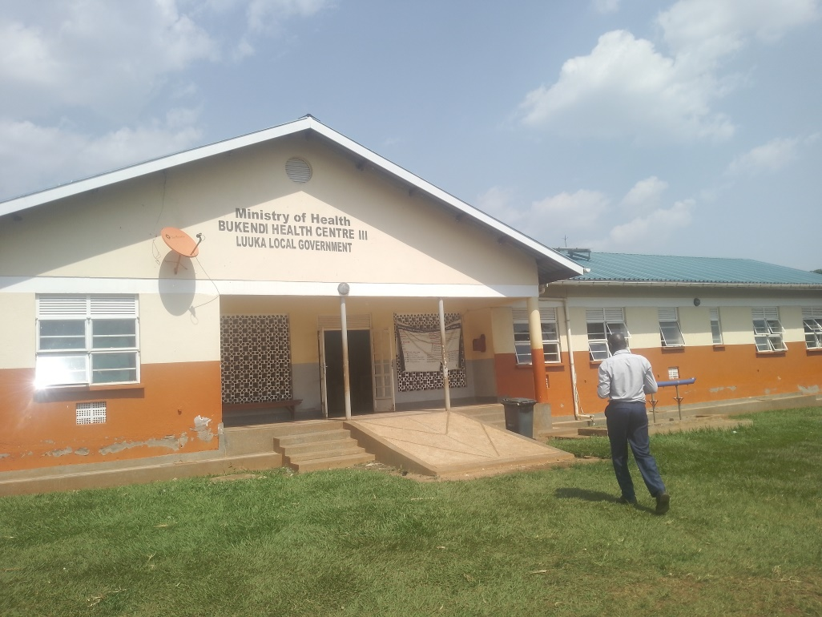
 | BENCHES  ENGRAVEMENT FORMAT (LDLG/UGFT/BUK HC) | 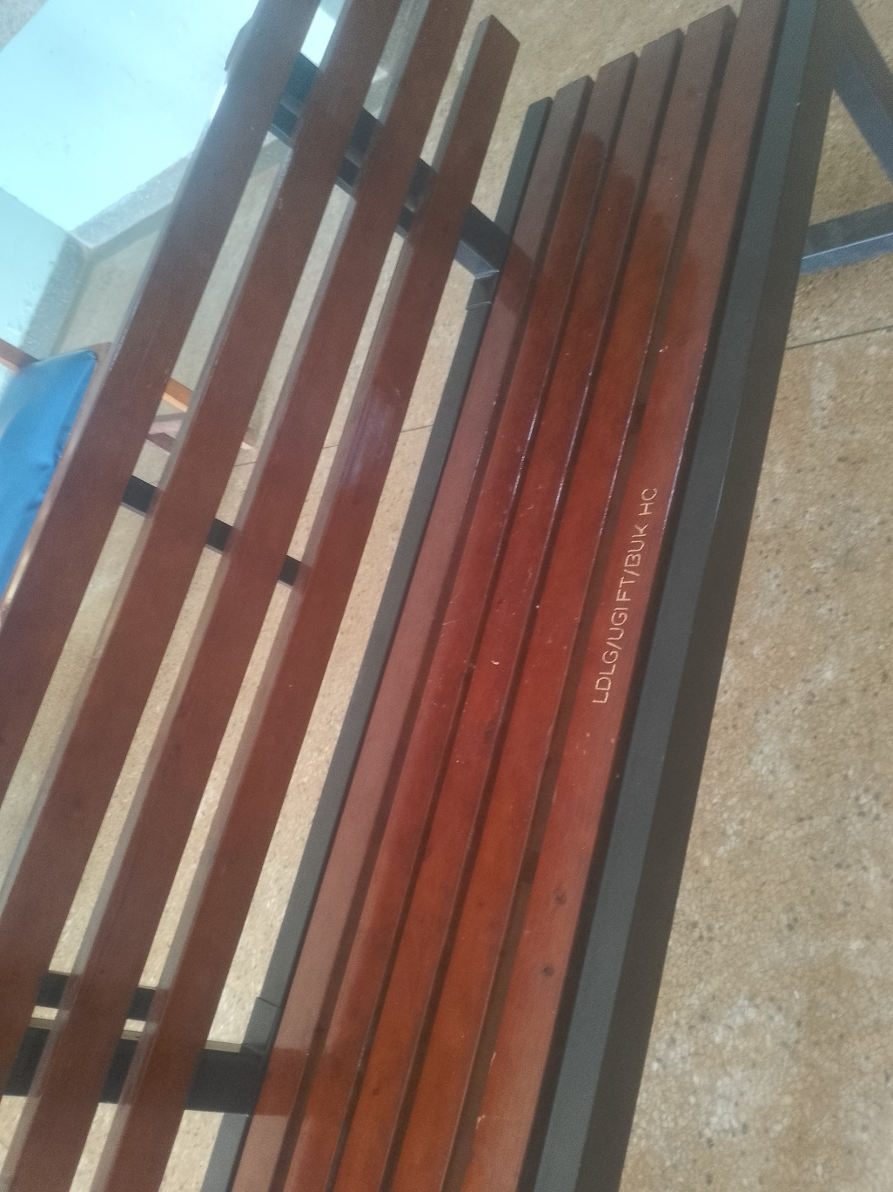
 | ENGRAVED BENCHES  AT BUKENDI HC III | 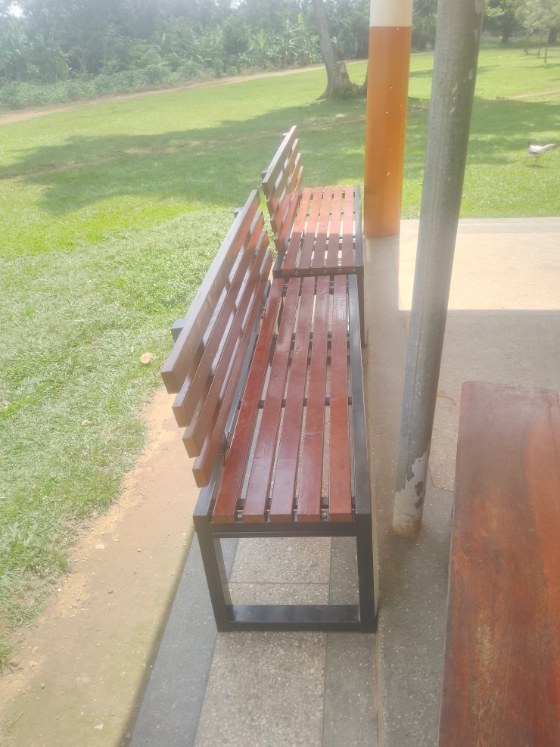
 | OFFICE CHAIRS | 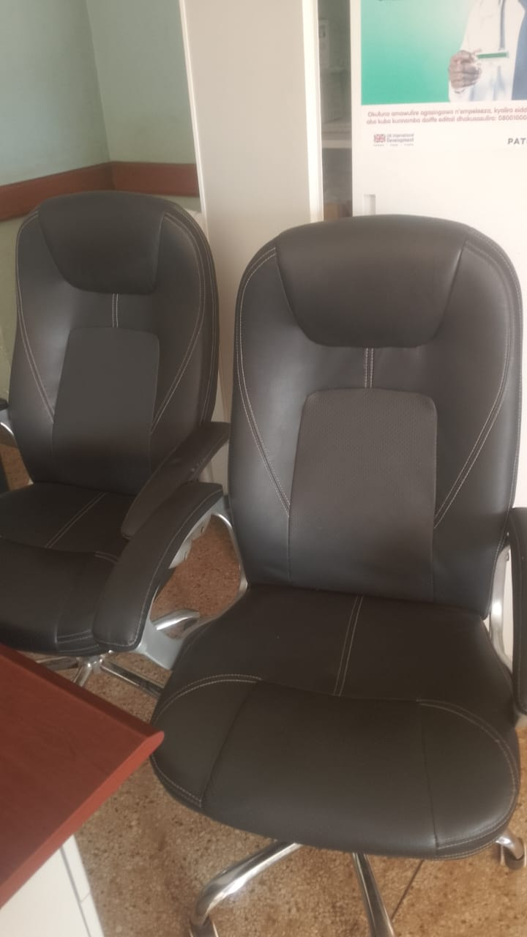
 | BINOCULAR MICROSCOPE | 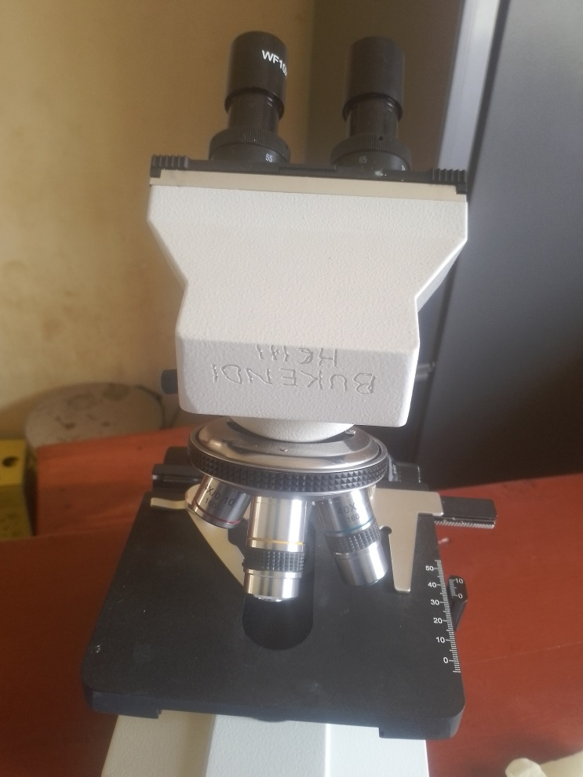
 | ONE OF THE 4 OXYGEN CONCETRATORS AT BUKENDI HEALTH CENTRE III | 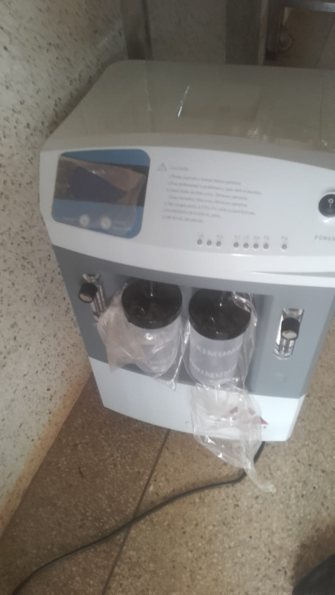
 | CENTRIFUGE  AT BUKENDI HC III | 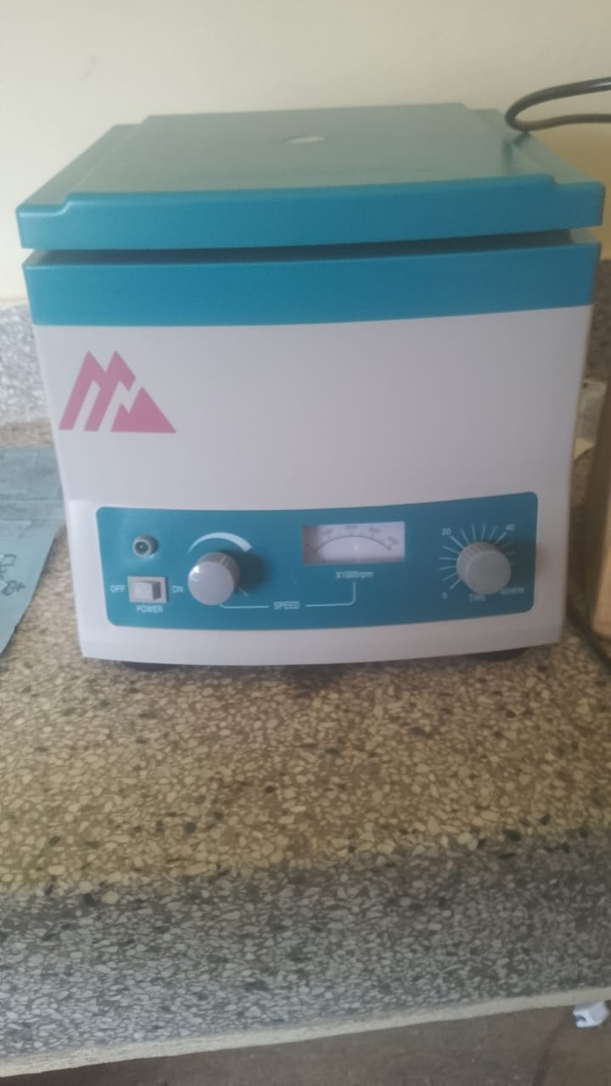
 | WEIGHING SCALE INFANT | 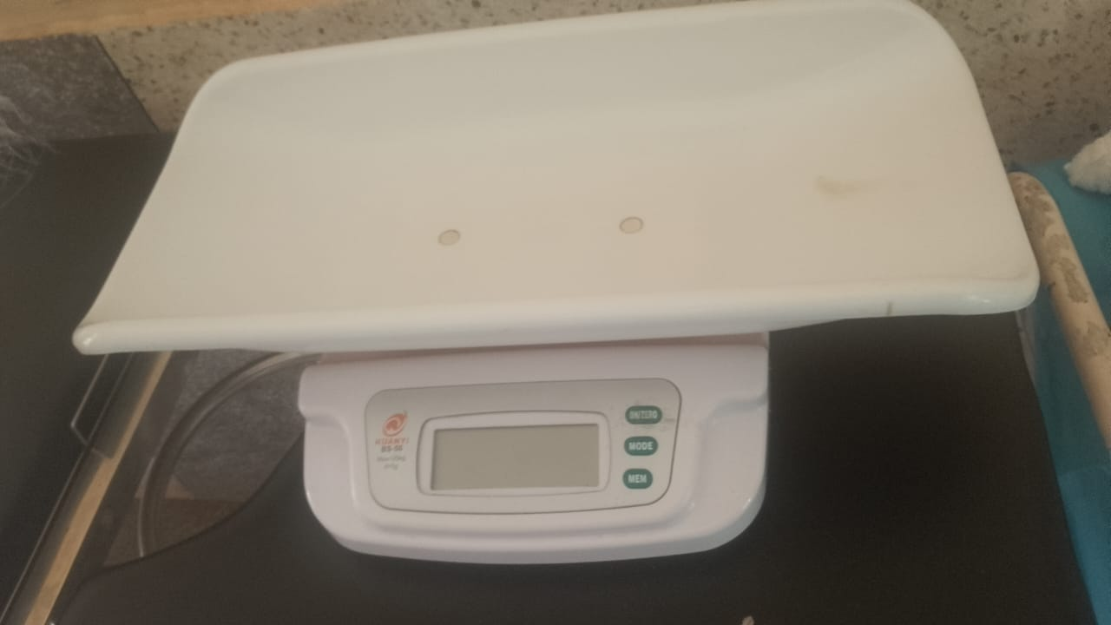
 | AUTOCLAVE | 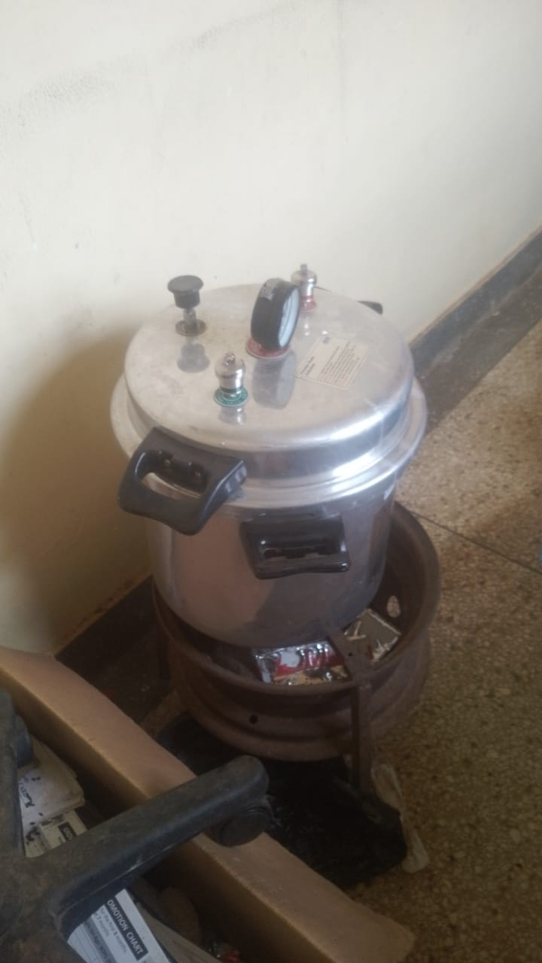
 | ADULT WEIGHING SCALE WITH HEIGHT METER | 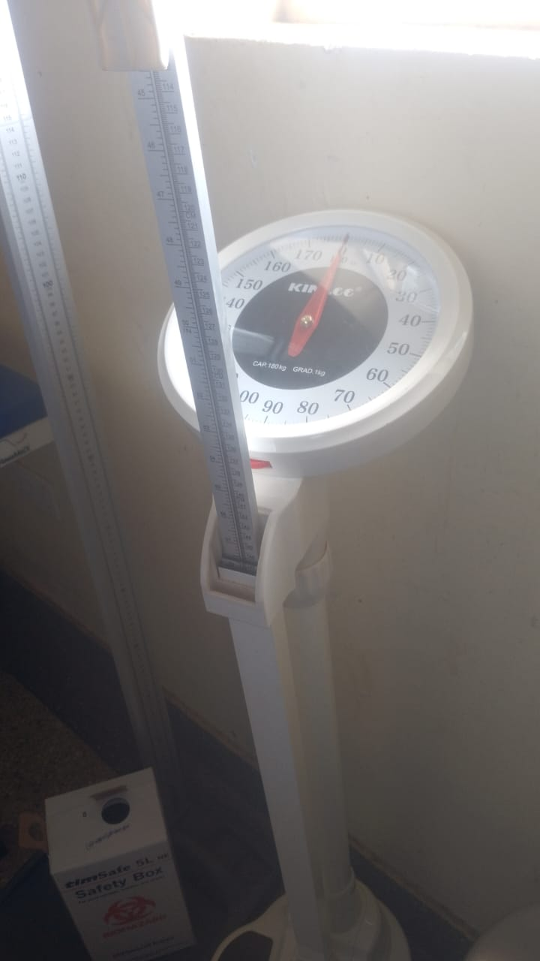
 | BP MACHINE ANEROID | 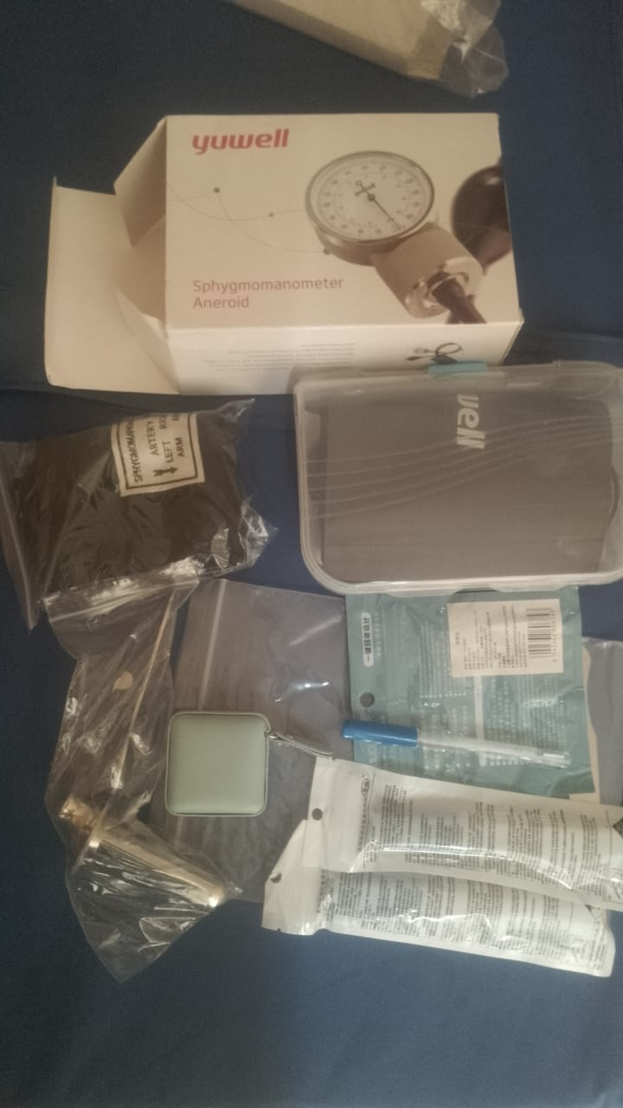
2. | BP MACHINE DIGITAL  NOT ENGRAVED | 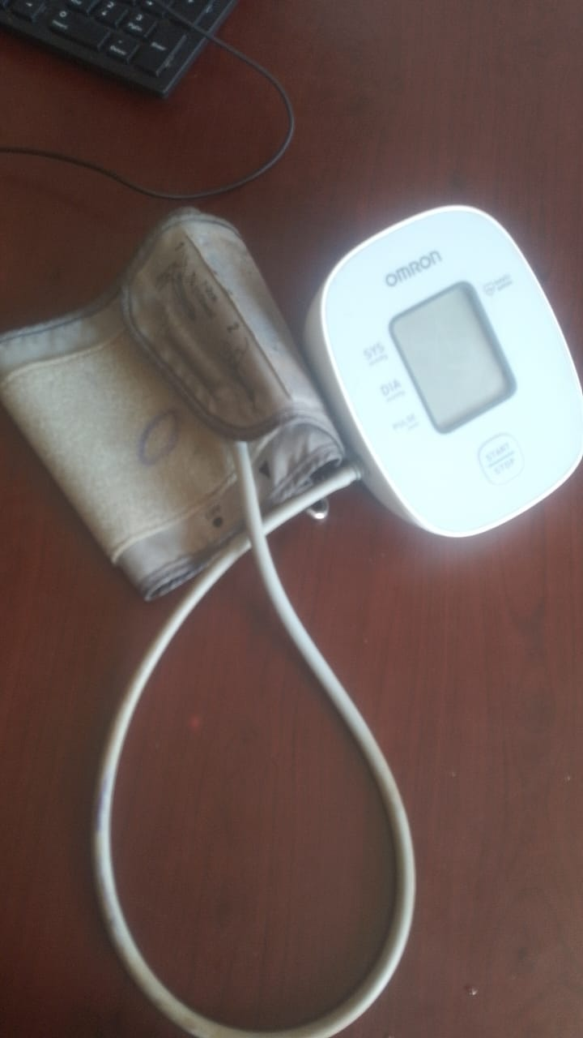
 | RESUSCITATOR  BVM (BIG VALVE MASK) | 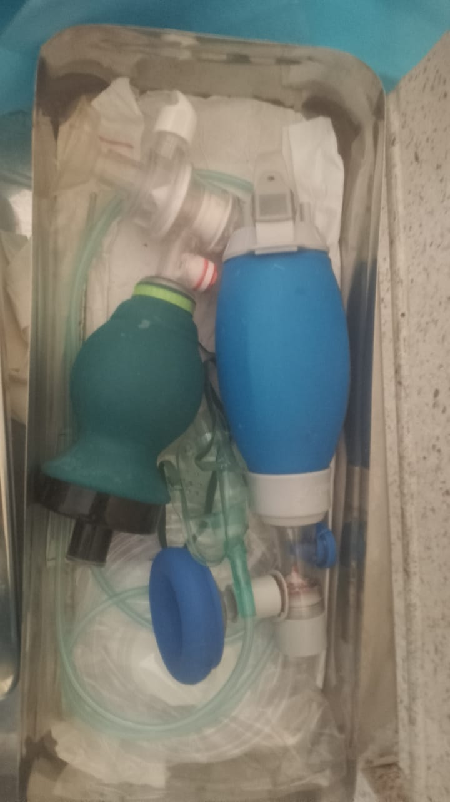
 | GLUCOMETER  (NOT ENGRAVED) | 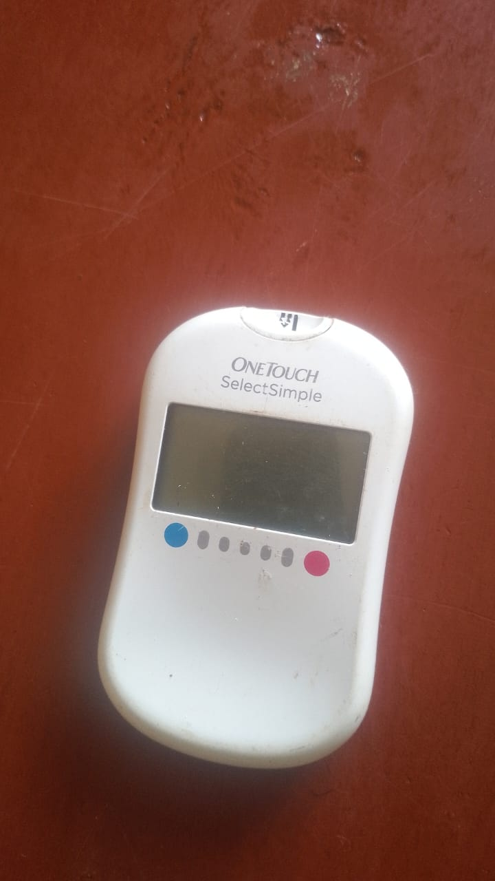
 | ESR STAND | 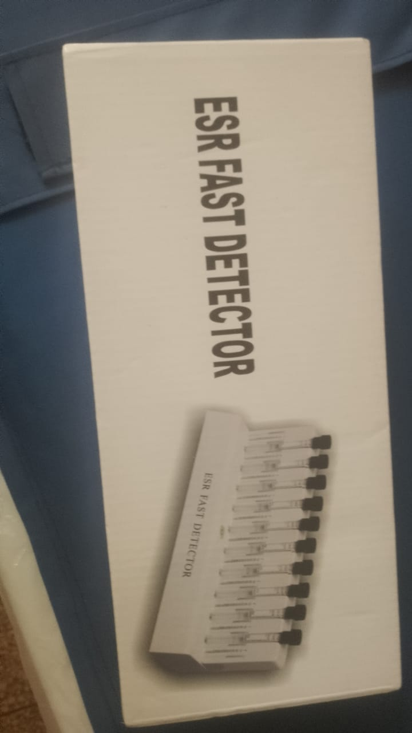
 | BOWL STAND WITH DOUBLE RINGS FOR BOWLS | 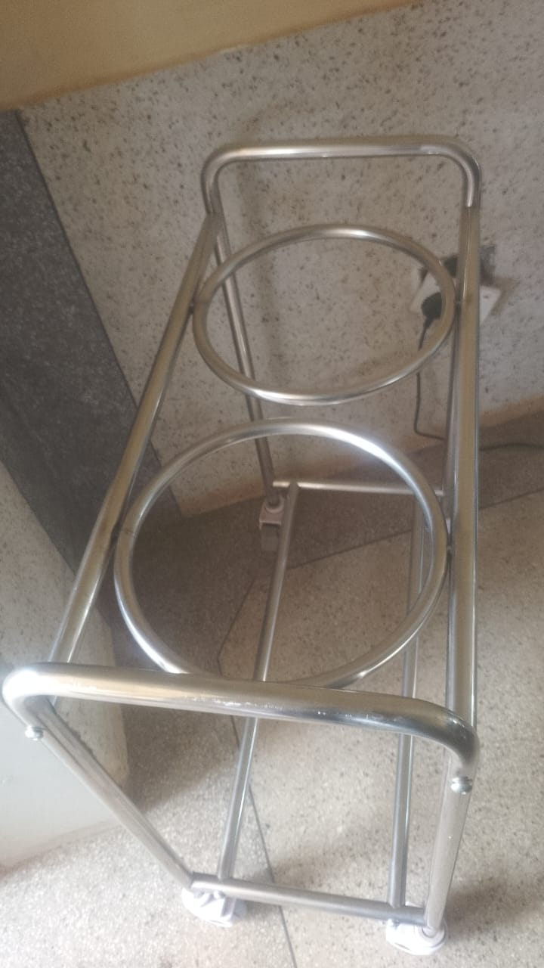
 | WELL ENGRAVED ADULT BEDS  7 STORED,  3 IN USE | 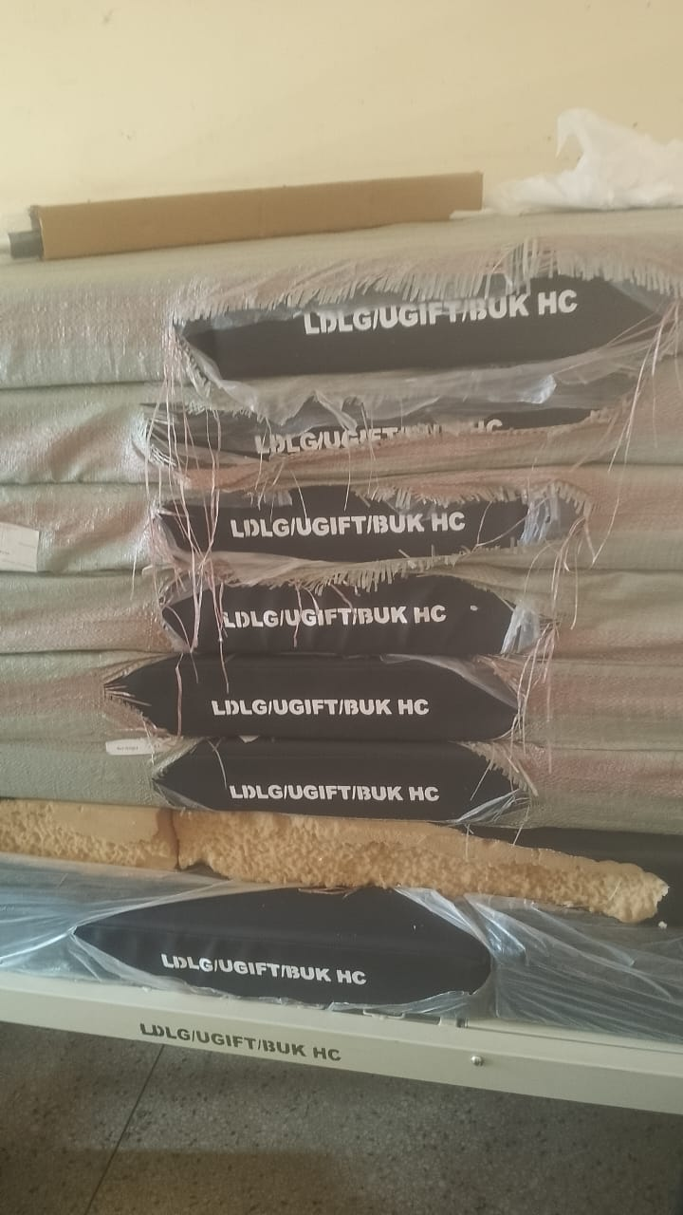
 | WELL ENGRAVED PATIENT TROLLEY | 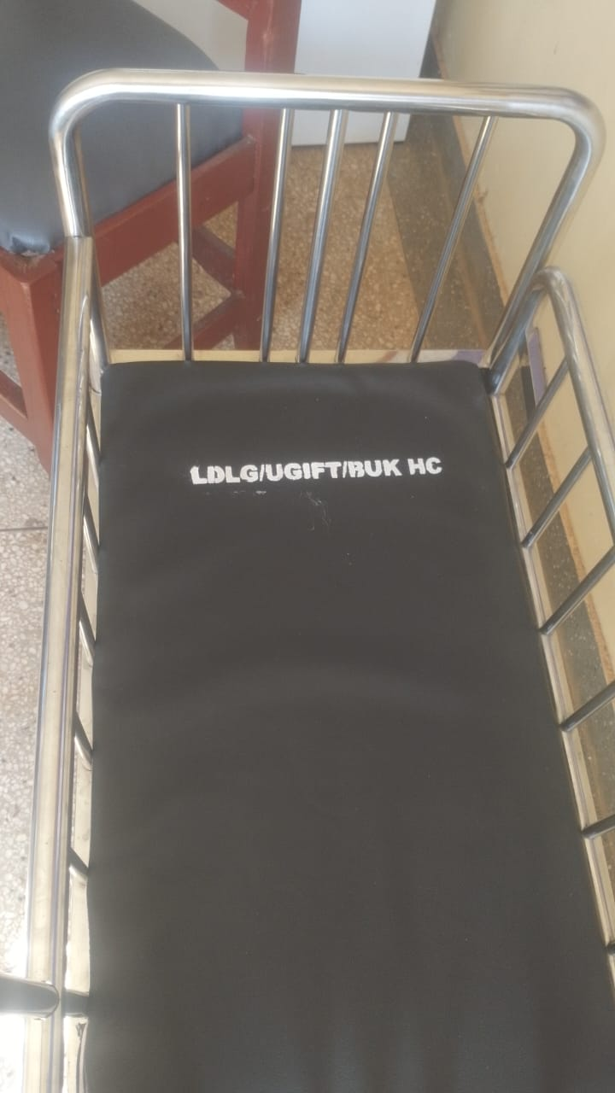
 | EXAMINATION COUCH  WELL ENGRAVED | 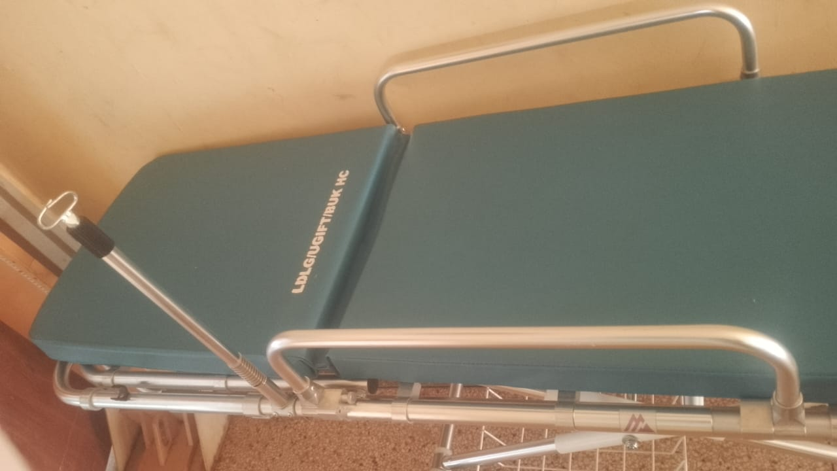
 | DELIVERY BED  WELL ENGRAVED | 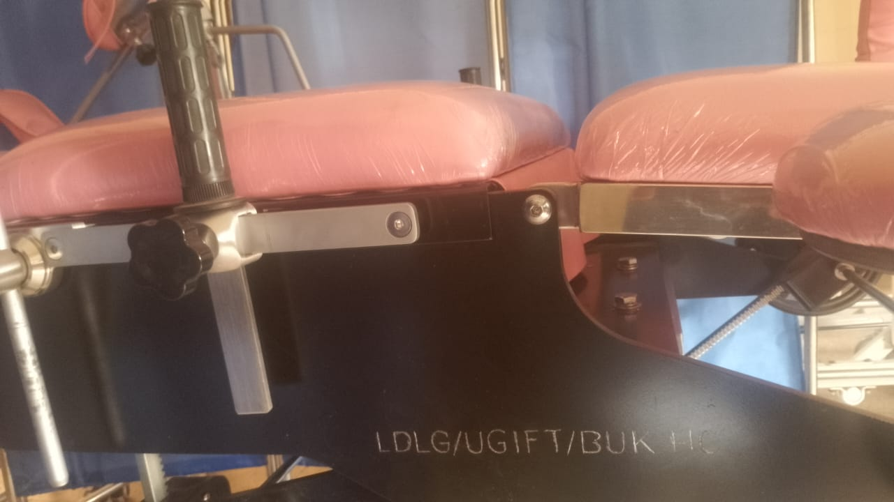
 | OFFICE TABLE | 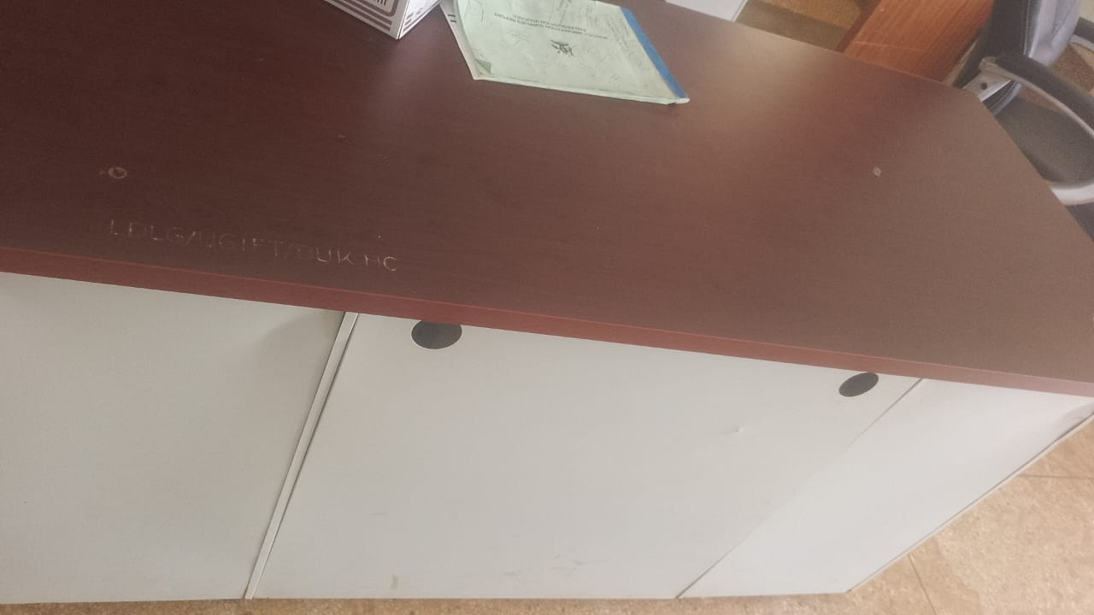
 | SMALL TANK RAISED ON METALLIC STANDS | 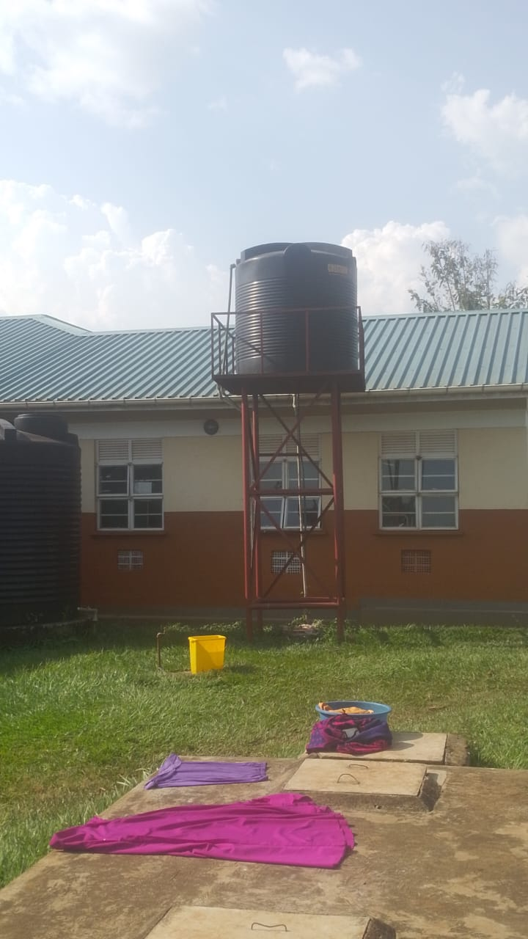
 | BIG TANK ON CIRCULAR CONCRETE | 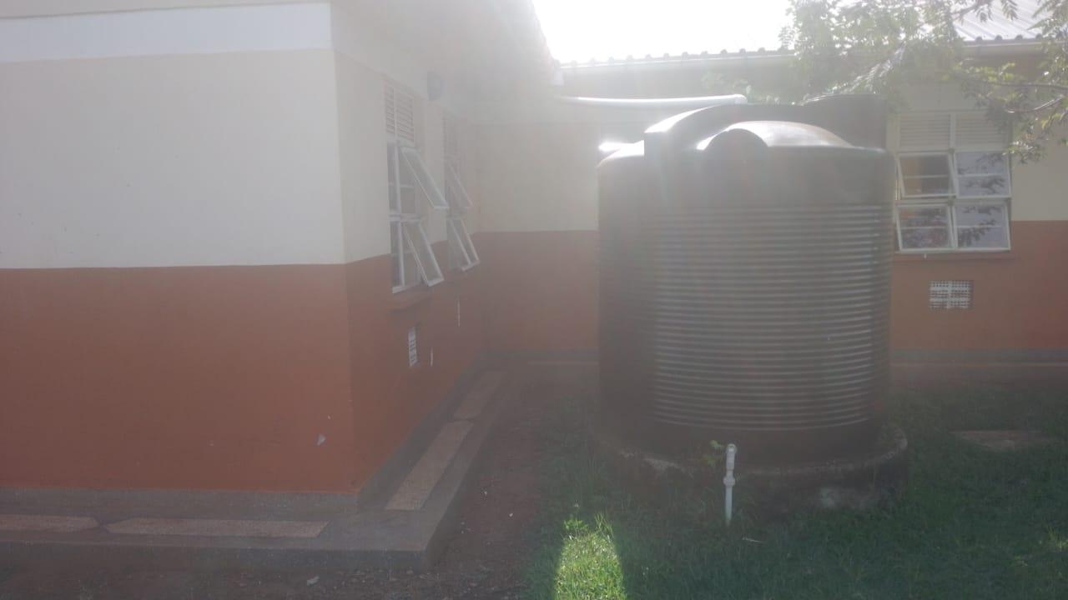
3. | TOILETS ENGRAVED MALE AND FEMALE | 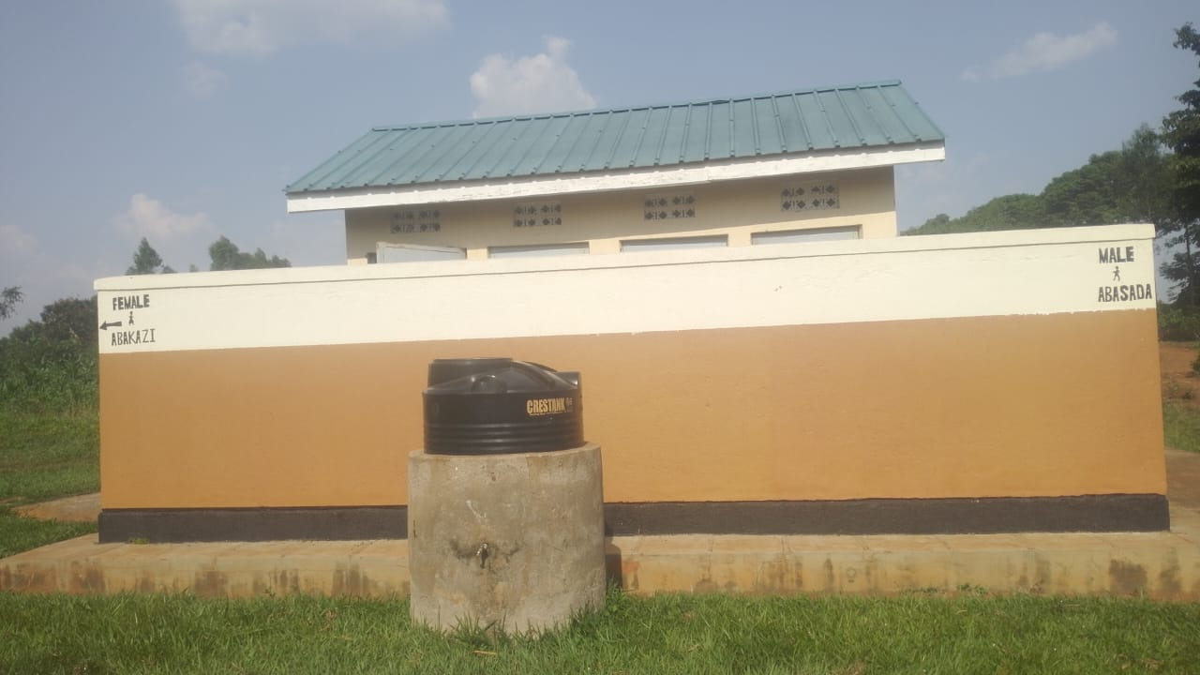
4. | ENGRAVED  PLACENTA PIT | 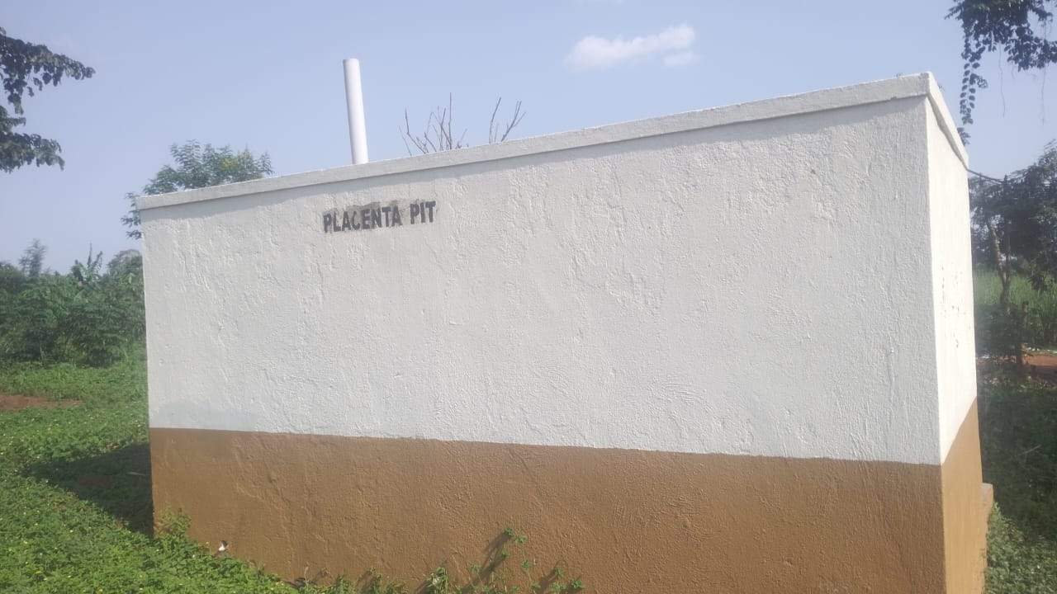

SCHOOL VERIFICATION CHECKLIST

